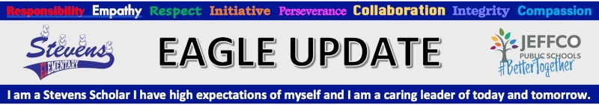


Tues 8/10 | School Office opens 8am-3pm - Masks are required for all visitors
Aug 13-15 | -Wheatridge Carnation Festival https://thecarnationfestival.com/  -If you would like to walk with Stevens in the Parade on Saturday morning, meet us near 38th and Ames at about 9:00, look for the Stevens Crew Float!
Tues 8/17 | -Orientation required for all students - more info below  -4pm-6pm, BETTER TOGETHER BBQ - Be prepared for BIG FUN and YUMMY FOOD! Masks required while not eating for all visitors.
Wed 8/18  First full day of school. | -8:00am - Free breakfast for students  -8:15am - First day of regular schedule school for all students. Line up procedures  -8:20am - Tardy bell rings, students arriving late must sign in at the office  -3:20pm - School ends for the day  -School office hours 7:30am-3:30pm
 | Printable Stevens Family Calendar
New! Jeffco Mask Requirements:
- Preschool students must wear masks
- Elementary students must wear masks
- Unvaccinated staff must wear a mask
- Vaccinated staff - recommended masking
- All visitors and volunteers to the school, any age, vaccinated or not, mask is required
See entire statement from Jeffco Public Schools here.
Enrollment - Going on Now!
Please see the Jeffco Registration Checklist For help or questions contact Vicki Zeimen 303-982-2198 vicki.zeimen@jeffco.k12.co.us
School Fees can be paid online through Jeffco Connect
Fill out your Free and Reduced Meal Application www.SchoolCafe.com. This link is also in Jeffco Connect. Why should you apply? See important information below.
School Supply Lists Click here
Action Center School Supply Distribution - Click for flyer Appointment required
Orientation for all students Tues Aug 17 - Your child’s teacher will be contacting you after Aug 9th to schedule a morning or afternoon orientation time. Kids will spend a couple hours with their teacher. This is required for all students. Parents will drop off and pick up kids for orientation.
Don’t miss our Better Together Back to School BBQ - Tuesday August 17, 4:00-6:00pm. We have some really fun stuff planned and can’t wait to welcome all of our Stevens Families back to school. This will be an outdoor event on the front lawn. Masks are required for unvaccinated adults and children.
Meet our new Family Engagement Liaison: We are excited to introduce you to Anita De Leon. Anita is anxious to meet all of our amazing students and their families. Click Here to learn more about her and the role she has here at Stevens.
Why Free & Reduced Meal Applications for All Families?
Benefits for your student and family
Free and Reduced Lunch application can be used to determine eligibility for:
· Pandemic EBT (P-EBT) benefits to help purchase food
· Discounted school fees
· Free or reduced internet service
· Discounted phone service
Benefits for your school
Schools receive important funding and resources based on the number of free and reduced applications.
Applying for free school meals is fast, easy, and secure. Even if you think you may not qualify, we encourage you to submit an application.
There are no immigration requirements to participate in the program.
Friends of Stevens PTO: friendsofstevens.org
Please consider attending a PTO meeting. We do great things for the kids and the staff at Stevens and love and depend on the support of our families and community.
Contact PTO President, Jen Cross if you’d like more info. or if you have any questions jenbowencross@gmail.com.
Meeting schedule:
Sept 9th - 6pm
Nov 11th - 6pm
Jan 13th - 6pm
Mar 10 - 6pm
May 12 - 6pm

Red Rocks Child Care - Please click HERE for more information regarding before and after school care. Registration opens Aug 2.

